Stacks

Introduction:

The linear lists and linear arrays – allowed one to insert and delete elements at any place in the list

- At the beginning
- At the end, or
- In the middle

To restrict insertion and deletions so that they can take place only at the beginning, or at the end of the list, not in the middle.

Two of the data structures that are useful are:

- Stacks
- Queue

stack:

A stack is a linear structure in which items may be added or removed only at one end.

Three everyday examples of such a structure

- Stack of dishes
- Stack of pennies
- Stack of folded towels

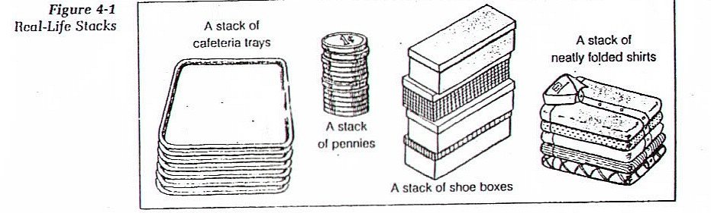

An item may be added or removed only from the TOP of any stacks.
This means, in particular that the last item to be added to stack is the first item to be removed

Stacks are called Last-in-first-out (LIFO) Lists.
STACKS are also called “PILES” AND “PUSH- DOWN”

STACKS

A stack is a list of elements in which an element may be inserted or deleted only at one end, called the “TOP” of the stack.

This means that elements are deleted from a stack in the reverse order of that in which they were inserted into the stack.

Two basic operations associated with stacks
- PUSH is the term to insert an element into a stack
- POP is the item to delete an element from a stack

Example
Suppose the following 6 elements are pushes in order onto an empty stack
AAA, BBB, CCC, DDD, EEE, FFF

 |  | Top | AAA
 |  |  | BBB
Top | FFF |  | CCC
 | EEE |  | DDD
 | DDD |  | EEE
 | CCC |  | FFF
 | BBB
 | AAA

AAA | BBB | CCC | DDD | EEE | FFF |  | …….
1 | 2 | 3 | 4 | 5 | 6 |  |  |  |  | N-1 | N
 |  |  |  |  | TOP
The implication is that the right most element is the top element.
In a stack insertions and deletions can occur only at the top of the stack.
The elements may be popped from the stack only in the reverse order of that in which they were pushed onto stack.

This means:
EEE cannot be deleted before FFF is deleted,
DDD cannot be deleted before EEE and FFF is deleted and so on.

POSTPONED DECISIONS

Stacks are frequently used to indicate the order of the processing of data when certain steps of the processing must be postponed until other conditions are fulfilled.

Suppose we have three procedures in a project A, B, C

 |  |  |  | C
 |  | B |  | B
A |  | A |  | A
(a) |  | (b) |  | (c)

ARRAY REPRESENTATION OF STACKS

STACKS may be represented by means of a linear array.

- Each of our STACKS will be maintained by linear array STACKS,
- A pointer variable TOP which contains the location of the top element of the stack,
- Variable MAXSTK, which gives the maximum number of elements that, can be held by the stack.

The Condition

TOP =0 or TOP= NULL indicate that stack is empty

XXX | YYY | ZZZ
1 | 2 | 3 | 4 | 5 | 6 | 7 | 8
 |  | Top=3 |  |  |  |  | MAXSTK=8

Stack has 3 elements => since TOP =3

There is room for 5 more items since MAXSTK =8
PUSH: the operation of Adding (Pushing) an item onto a stack
POP: the operation of removing (Popping) an item from a stack
Operations of Stack
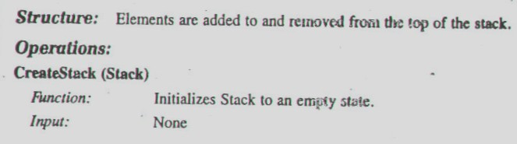

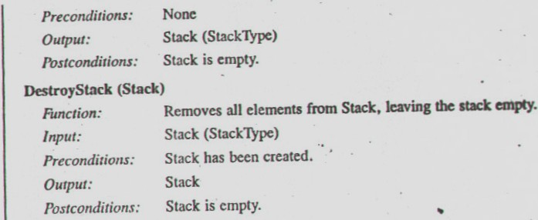

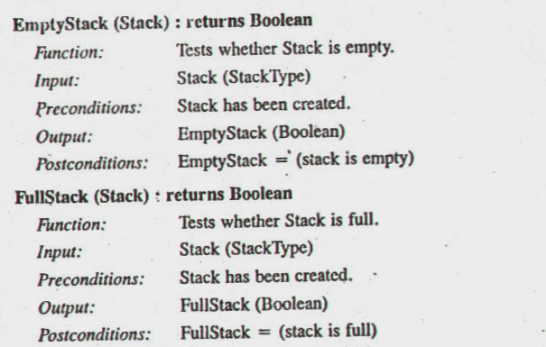

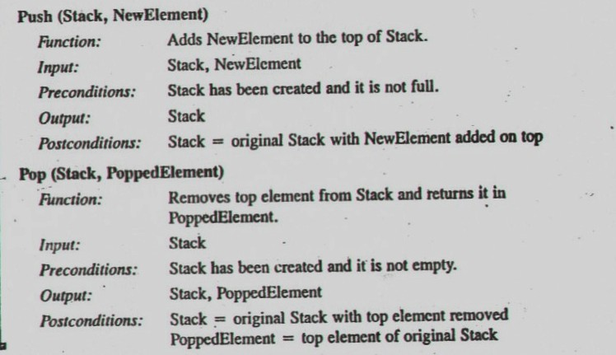

PUSH

In executing the procedure PUSH, one must first test whether there is ROOM in stack for the new item, if not, then we have the condition known as overflow.

PUSH (STACK, TOP, BOUND, ITEM)

Algorithm

- [Stack already filled?]
If IsFull() = True, then Print OVERFLOW and return
- Set TOP := TOP+1 [Increasing TOP by 1]
- Set Stack[TOP]:= ITEM [Insert ITEM in New TOS position ]
- Return

POP

In executing POP, one must first test whether there is an element in stack to be deleted, if not, then we have the condition known as underflow.

POP (STACK, TOP, BOUND, ITEM)

- If IsEmpty = True, then Print: UNDER FLOW & Return
[Stack has an item to be removed]
- Set ITEM := Stack[TOP] [Assigns Top elements to ITEM]
- if TOP = BOUND then TOP = NULL
- Else
  - Set TOP= TOP-1 [ Decrease TOP by 1]
- Return

Example:

Consider the stack, the operation PUSH (STACK, WWW)

- Since TOP =3 control is transferred to Step 2.
- Top=3+1=4
- Stack[Top]= Stack[4]=WWW
WWW is now the top element in the stack

XXX | YYY | ZZZ
1 | 2 | 3 | 4 | 5 | 6 | 7 | 8
 |  | Top=3 |  |  |  |  | MAXSTK=8

XXX | YYY | ZZZ | WWW
1 | 2 | 3 | 4 | 5 | 6 | 7 | 8
 |  |  | Top=4 |  |  |  | MAXSTK=8

Consider the stack, the operation POP (STACK, ITEM)

- Since TOP =3 control is transferred to Step 2.
- ITEM = ZZZ
- Top=3-1=2
- Return

Observe that STACK [TOP] = STACK [2] = YYY is now the top element in the stack
XXX | YYY | ZZZ
1 | 2 | 3 | 4 | 5 | 6 | 7 | 8
 |  | Top=3 |  |  |  |  | MAXSTK=8

XXX | YYY
1 | 2 | 3 | 4 | 5 | 6 | 7 | 8
 | Top=2 |  |  |  |  |  | MAXSTK=8

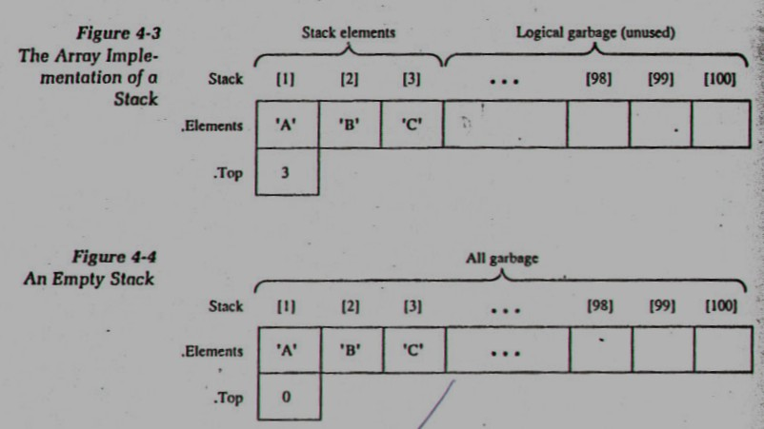

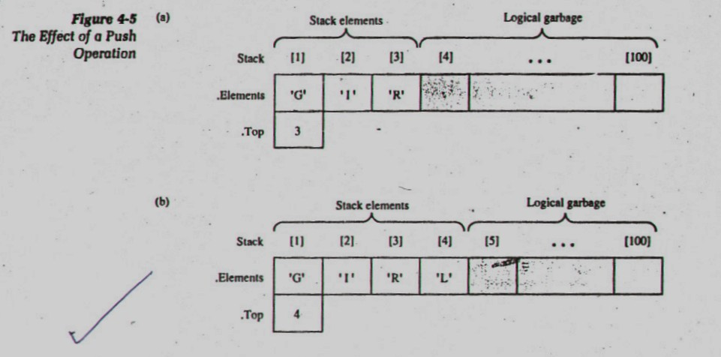

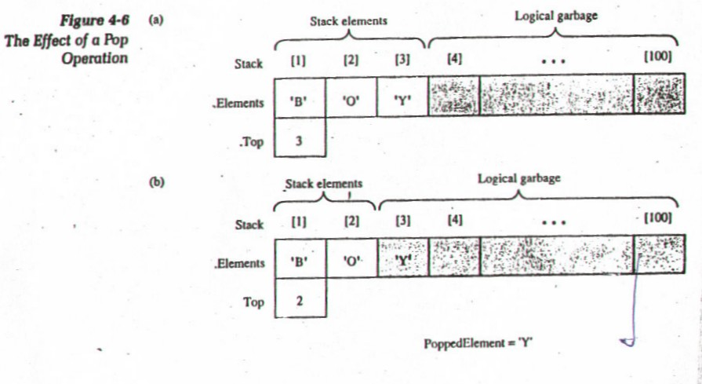

Minimizing Overflow:
Essential difference between underflow and overflow in dealing stacks

Underflow | Depends relatively upon the given algorithm and given input data and hence there is no direct control by the programmer
Overflow | Depends upon the arbitrary choice of the programmer for the amount of memory space reserved for each stack, and this choice does influence the number of times overflow may occur

